**Creative Brief**

Interaction Foundations Spring 2024

Max Douglass

**Project Title: Dune(novel) website**

1. ProjectOverview

This website should convey information about the novel Dune, but the information should be conveyed in a way that complements the style of the work. I believe the style/aesthetics of the site are important to convey the feel and themes of the book.

1. Resources

Content can come mostly from this Wikipedia page on the first book: <https://en.wikipedia.org/wiki/Dune_(novel)> There are other Wikipedia articles on the franchise as a whole and the movies, but the above page provides a good amount of information and should be enough. If needed, there is also a dune Wiki: <https://dune.fandom.com/wiki/Dune_Wiki>. Also, the movies are a great resource, the two Denis Villenueve movies that came out in 2021 and 2024 are part 1 and 2 of the first book.

1. Audience

This website is just for displaying the content of DUNE in an aesthetically pleasing way. It could be viewed by those interested in learning more about DUNE. It will also be used in class and could be used as part of my portfolio for web-design. The recent movies were quite popular so the interest in this could come from anyone.

1. Message

Overall, I think DUNE is a very interesting novel that brings up a lot of themes like ecology/conservation, cultural oppression, religion, and politics. It is also just aesthetically cool in my opinion, and I’d like to communicate the themes of DUNE, while also appreciating the worldbuilding and artistry of the creation of the novel.

1. Tone

The tone here should match the tone of the books if possible. I think the books have a kind of minimalistic and harshness to them. Most of the book takes place on a barren desert world. However, there is a certain beauty to the harshness, and I think that could be a good tone for the site. Simplistic, yet visually pleasing.

1. Visual Style

The new movies have a very distinct visual style, but there is a lot of artworks out there for DUNE that varies slightly. Overall, I think the style matches the tone, simple/minimalistic but beautiful. The visuals of DUNE are also very dramatic. Large open spaces. Some examples will be included below, from the movie but also from other sources.

**Images from movies**

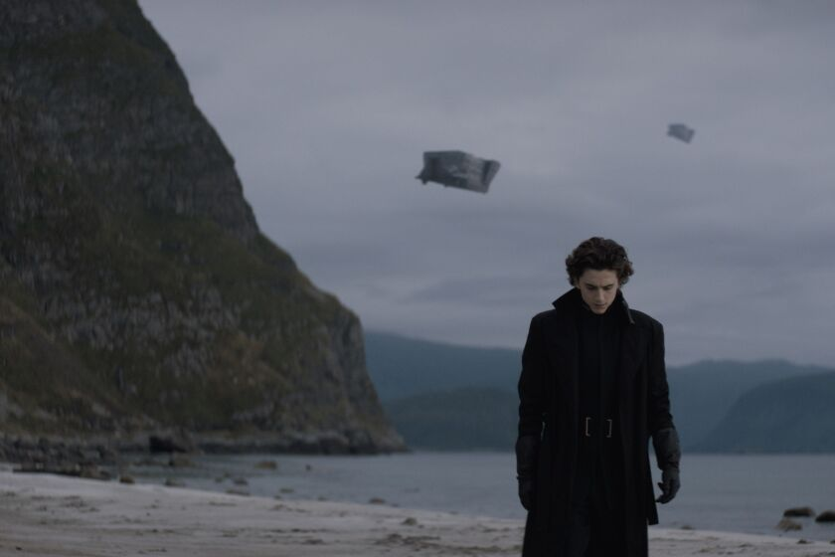

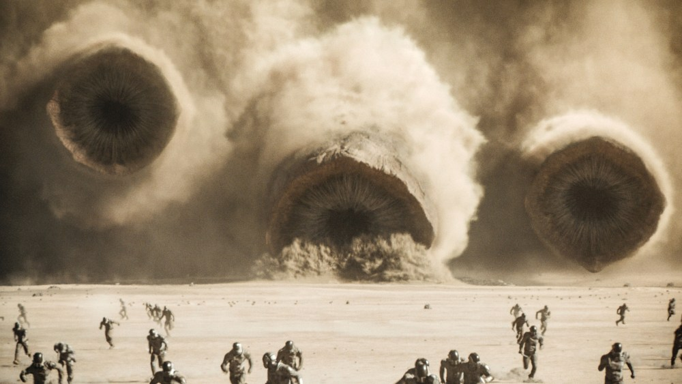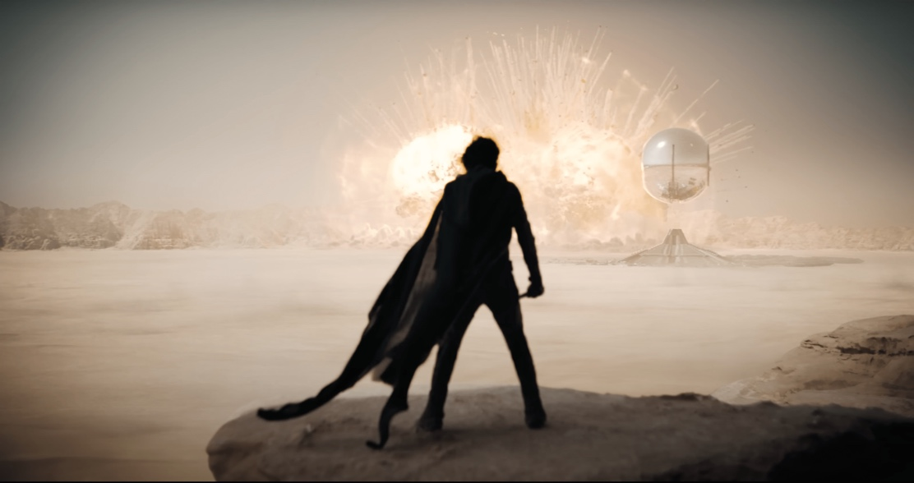

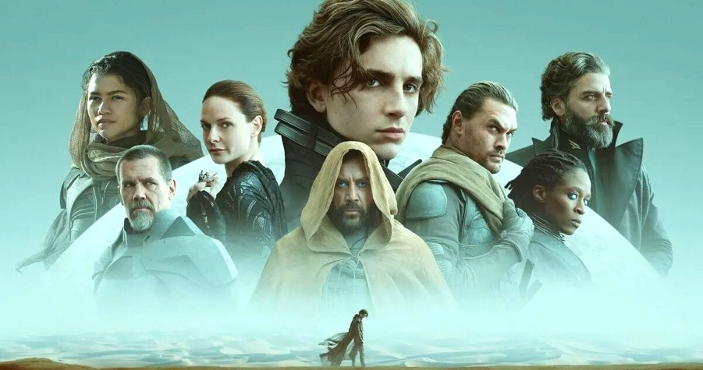

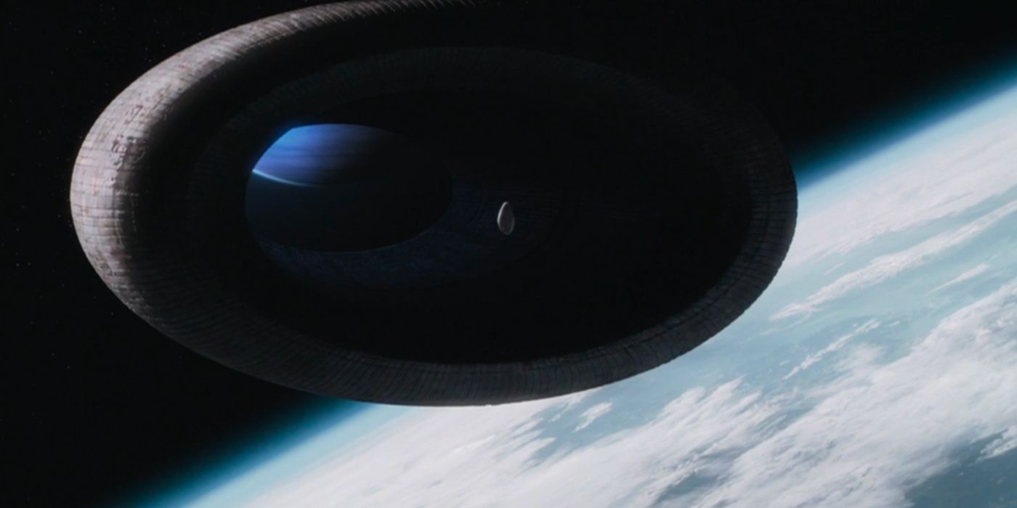

Video compilation with cool shots: <https://www.youtube.com/watch?v=pwOIbRB8tU0>

**Other Artwork:** <https://art.marcsimonetti.com/dune-by-frank-herbert>

